Use Case 5 : Smart Building Environmental Monitoring using Microsoft Fabric Real-Time Intelligence

Business Scenario
A multinational organization manages 200+ smart office buildings equipped with IoT sensors that continuously monitor environmental conditions.
Each sensor sends telemetry every few seconds containing:
- Temperature (°C)
- Humidity (%)
- Wind Speed
- Event Processed UTC Time

Objectives
• Create a KQL Database and KQL Table using Copilot.
• Ingest streaming IoT data into Eventstream.
• Transform streaming events using Eventstream built-in functions.
• Store transformed events in a KQL Database.
• Use Copilot to generate KQL queries for real-time analysis.
• Create a Real-Time Dashboard to monitor live sensor telemetry.

Architecture

IoT Sensor Data
│
▼
Eventstream
│
▼
Transform Data (Built-in Functions)
│
▼
KQL Database
│
▼
KQL Queries (Copilot)
│
▼
Real-Time Dashboard

Steps to Perform

- Create a new Microsoft Fabric Workspace and provision an Eventhouse and an Eventstream.

- Use Eventstream to ingest the data from Real-time weather source to a table in KQL Database.

Choose location - Bengaluru

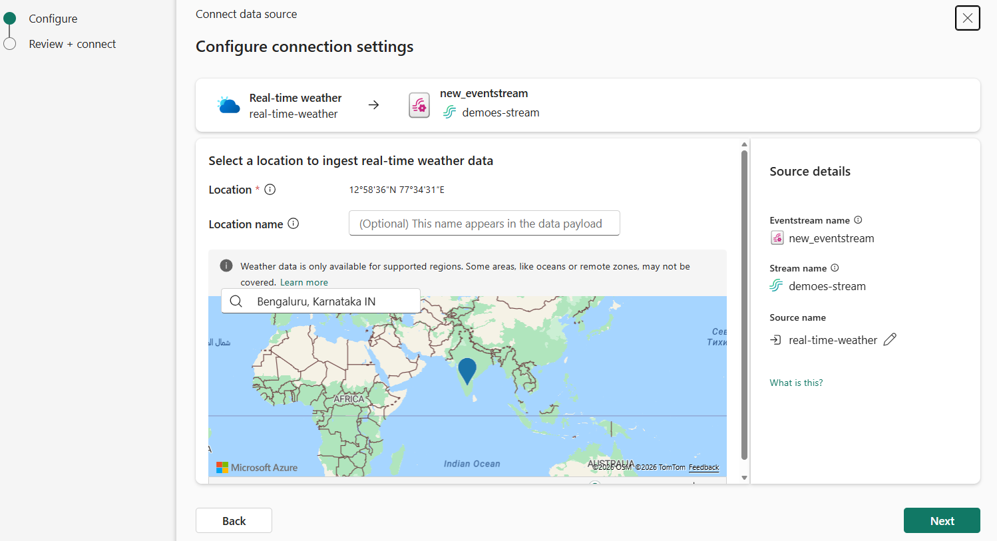

Add a Manage Fields Transformation to include these columns – temperature , Humidity, windspeed, dateTime and remove all the other columns
Change the datatypes of these columns to match the data types below:
temperature – Int64

Humidity – Int64

windspeed – Int64

dateTime – datetime

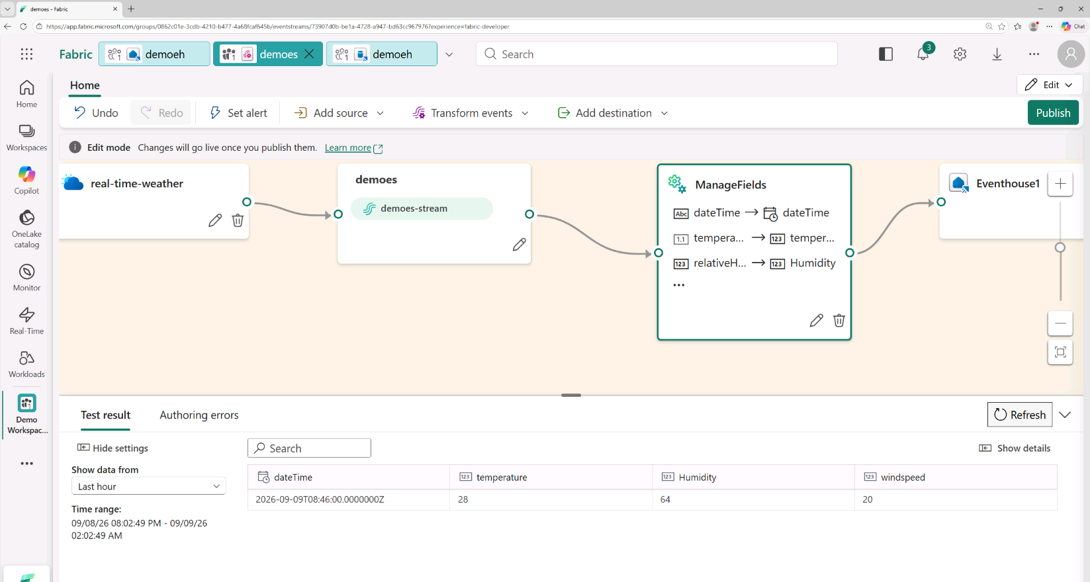

Create a table named SensorReadings with appropriate data types as the destination in Eventhouse

- Use Copilot to generate analytical KQL queries to answer questions such as:
- Average Temperature
- Average Humidity
- Average Wind Speed
- Highest Temperature
- Highest Humidity
- Highest Wind Speed

- Use Copilot to generate KQL queries and build a Real Time Dashboard and add tiles:
- Add a line chart showing temperature over time.
- Add a KPI showing the highest temperature today with Stat visual.
- Add a KPI showing the highest humidity today with Stat visual.
- Add a KPI showing the highest wind speed today with Stat visual.
- Add a table showing the latest 20 events.
- Create a bar chart showing temperature status distribution.
- Create a pie chart showing humidity status distribution.

Expected Deliverables (in the form of screen shots in word document)

8 screenshots are expected
- A KQL Database with a SensorReadings table – 1 screenshot
- An Eventstream ingesting streaming telemetry – 1 screenshot
- Eventstream transformations using built-in functions to remove unnecessary fields and change data types – 1 screenshot
- Multiple Copilot-generated KQL queries for operational analysis and their output – 6 screenshots
- A Real-Time Dashboard displaying live KPIs, trends, alerts, and recent events for facilities monitoring – 1 screenshot covering all the visuals

